# OOP Lab 11 Outputs

Name: Saahil Ghulam Mohammad

Roll Number: 24K-0570

Section: BCS-2D

Task 1: 

Task 2: 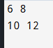

Task 3: 

Task 4: 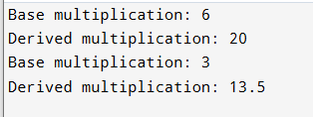

Task 5: 